MAU 1: LANI & DANI (GOLF COMPANY)

1.1 Navbar + Hero Carousel
<nav class="navbar navbar-expand-lg bg-white shadow-sm">
<div class="container-fluid px-4">
<a class="navbar-brand fw-bold" href="#">
<img src="logo.png" height="40"> LANI & DANI
</a>
<button class="navbar-toggler" data-bs-toggle="collapse" data-bs-target="#nav1">
<span class="navbar-toggler-icon"></span>
</button>
<div class="collapse navbar-collapse" id="nav1">
<ul class="navbar-nav ms-auto">
<li class="nav-item"><a class="nav-link active" href="#">TRANG CHU</a></li>
<li class="nav-item"><a class="nav-link" href="#">LIEN HE</a></li>
</ul>
</div>
</div>
</nav>

<!-- Carousel full width -->
<div id="heroCarousel" class="carousel slide" data-bs-ride="carousel">
<div class="carousel-inner">
<div class="carousel-item active">
<img src="golf1.jpg" class="d-block w-100" style="height:500px;object-fit:cover;">
</div>
</div>
<button class="carousel-control-prev" data-bs-target="#heroCarousel" data-bs-slide="prev">
<span class="carousel-control-prev-icon"></span>
</button>
<button class="carousel-control-next" data-bs-target="#heroCarousel" data-bs-slide="next">
<span class="carousel-control-next-icon"></span>
</button>
</div>

1.2 About Us - 2 cot (text trai + 2 anh xep lech phai)
Pattern: row -> col-md-6 (text) | col-md-6 (2 anh con: col-7 + col-5)
<section class="py-5">
<div class="container">
<div class="row align-items-center g-4">

<div class="col-md-6">
<p class="text-muted mb-1">Chung toi la ai?</p>
<h2 class="fw-bold text-success mb-3">Cong ty LANI & DANI</h2>
<p>Tu hao la cong ty dau tien tai Viet Nam...</p>
</div>

<div class="col-md-6">
<div class="row g-2">
<div class="col-7">
<img src="golfer1.jpg" class="img-fluid rounded shadow">
</div>
<div class="col-5">
<img src="golfer2.jpg" class="img-fluid rounded shadow">
</div>
</div>
</div>

</div>
</div>
</section>

1.3 Service Cards - heading giua + luoi 3 cot x 2 hang
<section class="py-5 bg-light">
<div class="container">
<div class="text-center mb-5">
<p class="text-success fw-semibold mb-1">Chuyen gia hang dau</p>
<h2 class="fw-bold">Dich Vu San Golf</h2>
<p class="text-muted mx-auto" style="max-width:600px;">
Voi doi ngu thiet ke va xay dung chuyen nghiep...
</p>
</div>

<div class="row row-cols-1 row-cols-md-3 g-4">
<div class="col">
<img src="design.jpg" class="img-fluid rounded mb-3">
<h5 class="text-center">Thiet Ke</h5>
<p class="text-center text-muted">Doi ngu thiet ke san golf hon 10 nam...</p>
</div>
<!-- lap lai 5 col nua cho du 6 box -->
</div>
</div>
</section>

1.4 Icon Grid - 4 cot x 2 hang (Cac Dich Vu Khac)
<section class="py-5">
<div class="container">
<div class="text-center mb-5">
<h2 class="fw-bold">Cac Dich Vu Khac</h2>
</div>

<div class="row row-cols-2 row-cols-md-4 g-4 text-center">
<div class="col">
<div class="border rounded p-4 h-100">
<img src="icon-house.png" width="60" class="mb-3">
<p class="fw-semibold mb-0">Xay dung nha o</p>
</div>
</div>
<!-- lap lai 7 box nua -->
</div>
</div>
</section>

1.5 CTA Section - Form tren nen anh (overlay)
<section class="position-relative py-5"
style="background:url('golf-bg.jpg') center/cover; min-height:400px;">
<div class="position-absolute top-0 start-0 w-100 h-100 bg-dark opacity-50"></div>

<div class="container position-relative" style="z-index:2;">
<div class="row align-items-center">

<div class="col-md-5 text-white">
<div class="border border-light rounded p-4">
<img src="icon-chat.png" width="50">
<h3 class="fw-bold mt-2">Ban dang can tu van?</h3>
<p>Dung ngan ngai, hay lien he ngay...</p>
</div>
</div>

<div class="col-md-7">
<div class="bg-white rounded shadow p-4">
<form>
<div class="row g-3">
<div class="col-md-6">
<label for="ctaName" class="visually-hidden">Ten</label>
<input id="ctaName" class="form-control" placeholder="Ten cua ban">
</div>
<div class="col-md-6">
<label for="ctaEmail" class="visually-hidden">Email</label>
<input id="ctaEmail" class="form-control" placeholder="Email cua ban">
</div>
<div class="col-12">
<textarea class="form-control" rows="3" placeholder="Noi dung"></textarea>
</div>
<div class="col-12">
<button class="btn btn-success w-100">GUI</button>
</div>
</div>
</form>
</div>
</div>

</div>
</div>
</section>

1.6 Blog/Tin tuc - 2 Card lon + Sidebar list nho
<div class="row g-4">

<!-- 2 card lon -->
<div class="col-md-4">
<img src="news1.jpg" class="img-fluid rounded mb-2">
<h6 class="fw-bold">Nhung luu y quan trong trong cach chon golf cho nam</h6>
<small class="text-muted">Thang Muoi 28, 2020</small>
<p class="text-muted small mt-2">Theo chan cac golfer nam...</p>
<a href="#" class="btn btn-outline-success btn-sm">CHI TIET</a>
</div>

<div class="col-md-4"><!-- lap lai cau truc card 1 --></div>

<!-- Sidebar list nho -->
<div class="col-md-4">
<div class="d-flex mb-3">
<img src="thumb1.jpg" width="70" class="rounded me-2">
<div>
<small class="text-success">HOI DAP</small>
<p class="mb-0 fw-semibold small">Golf Course la gi?</p>
</div>
</div>
<!-- lap lai d-flex cho moi item -->
</div>

</div>

1.7 Footer - 3 cot + thanh copyright
<footer class="bg-dark text-light pt-5">
<div class="container">
<div class="row g-4">
<div class="col-md-4">
<img src="logo-white.png" height="40" class="mb-2">
<p class="text-muted small">Lani & Dani la cong ty hoat dong da nganh...</p>
</div>
<div class="col-md-4">
<h6 class="text-uppercase">Lien He</h6>
<p class="small mb-1"><strong>Dia chi</strong><br>202 Nguyen Van Huong...</p>
</div>
<div class="col-md-4">
<h6 class="text-uppercase">Tin Tuc</h6>
<ul class="list-unstyled small">
<li><a href="#" class="text-light">Ky thuat Golf</a></li>
</ul>
</div>
</div>
</div>

<div class="border-top border-secondary mt-4 py-3">
<div class="container d-flex justify-content-between">
<small>Copyright 2021 © LANI & DANI Company</small>
<div>
<a href="#" class="text-light me-2"><i class="bi bi-facebook"></i></a>
</div>
</div>
</div>
</footer>

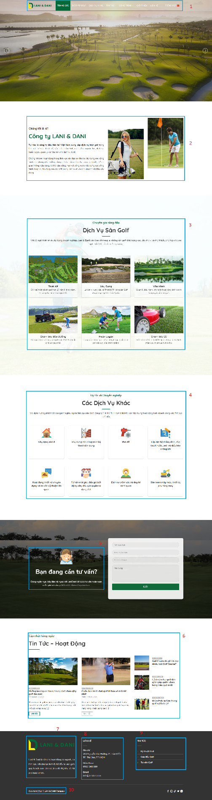

MAU 2: KIDKINDER (GIAO DUC TRE EM)

2.1 Hero 2 cot nen mau (full-bleed)
<section class="py-5" style="background:#1aa3a8;">
<div class="container">
<div class="row align-items-center">

<div class="col-md-6 text-white">
<p class="text-uppercase small mb-2">Kids Learning Center</p>
<h1 class="fw-bold display-5">New Approach to Kids Education</h1>
<p class="my-3">Sea ipsum kasd eirmod kasd magna...</p>
<button class="btn btn-dark rounded-pill px-4">Learn More</button>
</div>

<div class="col-md-6 text-center">
<img src="kid-reading.jpg" class="img-fluid"
style="clip-path: ellipse(48% 50% at 50% 50%);">
</div>

</div>
</div>
</section>

💡 Lưu ý
Hieu ung anh dang dam may dung CSS clip-path hoac anh PNG nen trong suot.
Khong can thu vien gi them.

2.2 Icon Grid khong vien - 3 cot x 2 hang
<section class="py-5">
<div class="container">
<div class="row row-cols-1 row-cols-md-3 g-4">

<div class="col">
<div class="bg-light p-4 h-100 d-flex">
<img src="icon-playground.png" width="40" class="me-3">
<div>
<h6 class="fw-bold">Play Ground</h6>
<p class="text-muted small mb-0">Kasd labore kasd et dolor est...</p>
</div>
</div>
</div>
<!-- lap lai 5 o nua -->

</div>
</div>
</section>

2.3 About - Anh trai + Text phai kem Checklist + Anh nho
<section class="py-5">
<div class="container">
<div class="row align-items-center g-4">

<div class="col-md-5">
<img src="family.jpg" class="img-fluid rounded">
</div>

<div class="col-md-7">
<p class="text-info text-uppercase small mb-1">Learn About Us</p>
<h2 class="fw-bold">Best School For Your Kids</h2>
<p class="text-muted">Invidunt lorem justo sanctis clita...</p>

<div class="row align-items-center">
<div class="col-5">
<img src="kid-write.jpg" class="img-fluid rounded">
</div>
<div class="col-7">
<p class="mb-1"><i class="bi bi-check-circle text-success"></i> Labore eos amet</p>
<p class="mb-0"><i class="bi bi-check-circle text-success"></i> Diam dolor diam</p>
</div>
</div>

<button class="btn btn-info text-white rounded-pill mt-3 px-4">Learn More</button>
</div>

</div>
</div>
</section>

2.4 Class Cards - 3 cot, co bang thong tin trong card
<div class="row row-cols-1 row-cols-md-3 g-4">
<div class="col">
<div class="card h-100 border-0 shadow-sm">
<img src="class1.jpg" class="card-img-top">
<div class="card-body text-center">
<h5>Drawing Class</h5>
<p class="text-muted small">Justo ea diam stet diam non sit...</p>

<table class="table table-sm text-start mb-3">
<tr><td>Age of Kids</td><td class="text-end">3 - 6 Years</td></tr>
<tr><td>Total Seats</td><td class="text-end">40 Seats</td></tr>
<tr><td>Class Time</td><td class="text-end">08:00 - 10:00</td></tr>
<tr><td>Tution Fee</td><td class="text-end">$290 / Month</td></tr>
</table>

<button class="btn btn-info text-white rounded-pill px-4">Join Now</button>
</div>
</div>
</div>
<!-- lap lai cho 2 class con lai -->
</div>

LUU Y QUAN TRONG:
Day la truong hop DUY NHAT nen dung <table> - vi no hien thi du lieu key-value
(Age, Seats, Time, Fee), KHONG phai dung de dan layout trang.

2.5 2 cot: Noi dung trang + Form nen toi (Book a Seat)
<section class="py-5">
<div class="container">
<div class="row align-items-center g-4">

<div class="col-md-6">
<p class="text-info small text-uppercase">Book A Seat</p>
<h2 class="fw-bold">Book A Seat For Your Kid</h2>
<p class="text-muted">Invidunt lorem justo sanctis clita...</p>
<p><i class="bi bi-check2 text-success"></i> Labore eos amet dolor amet diam</p>
<button class="btn btn-info text-white rounded-pill px-4">Book Now</button>
</div>

<div class="col-md-6">
<div class="p-4" style="background:#0d3b4f;">
<h4 class="text-white text-center mb-4">Book A Seat</h4>
<form>
<div class="mb-3">
<label for="bName" class="visually-hidden">Ten</label>
<input id="bName" class="form-control" placeholder="Your Name">
</div>
<div class="mb-3">
<label for="bEmail" class="visually-hidden">Email</label>
<input id="bEmail" class="form-control" placeholder="Your Email">
</div>
<div class="mb-3">
<label for="bClass" class="visually-hidden">Lop</label>
<select id="bClass" class="form-select">
<option>Select A Class</option>
</select>
</div>
<button class="btn btn-info text-white w-100">Book Now</button>
</form>
</div>
</div>

</div>
</div>
</section>

2.6 Footer 4 cot + Form Newsletter
<footer class="text-light pt-5" style="background:#0a2540;">
<div class="container">
<div class="row g-4">
<div class="col-md-3">
<h4>KidKinder</h4>
<p class="text-muted small">Labore dolor amet eos dolor...</p>
</div>
<div class="col-md-3">
<h6 class="text-info">Get In Touch</h6>
<p class="small"><i class="bi bi-geo-alt"></i> 123 Street, New York</p>
</div>
<div class="col-md-3">
<h6 class="text-info">Quick Links</h6>
<ul class="list-unstyled small">
<li><a href="#" class="text-light">Home</a></li>
</ul>
</div>
<div class="col-md-3">
<h6 class="text-info">Newsletter</h6>
<form>
<label for="nlName" class="visually-hidden">Ten</label>
<input id="nlName" class="form-control mb-2" placeholder="Your Name">
<label for="nlEmail" class="visually-hidden">Email</label>
<input id="nlEmail" class="form-control mb-2" placeholder="Your Email">
<button class="btn btn-info text-white w-100">Submit Now</button>
</form>
</div>
</div>
</div>
</footer>

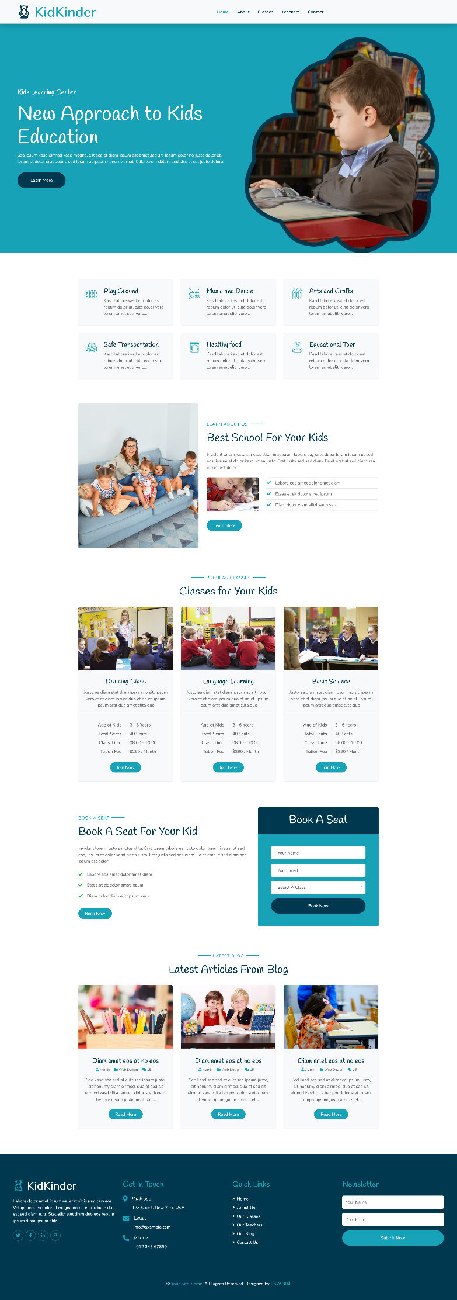

MAU 3: VIOLET ON WEDNESDAY (SHOP HOA)

3.1 Topbar + Header (logo/search/cart) + Navbar
<!-- Topbar -->
<div class="bg-light border-bottom small py-1">
<div class="container d-flex justify-content-between">
<div>
<i class="bi bi-telephone"></i> Hotline: 0968 159 239
<i class="bi bi-geo-alt ms-3"></i> 01 Nguyen Cuu Van, Binh Thanh
</div>
<div><a href="#">Dang nhap</a> hoac <a href="#">Tao tai khoan moi</a></div>
</div>
</div>

<!-- Header chinh: logo + search + cart -->
<div class="container py-3">
<div class="row align-items-center">
<div class="col-md-3">
<img src="logo.png" height="55">
</div>
<div class="col-md-6">
<div class="input-group">
<label for="searchBox" class="visually-hidden">Tim kiem</label>
<input id="searchBox" class="form-control" placeholder="Tim kiem...">
<button class="btn btn-outline-secondary"><i class="bi bi-search"></i></button>
</div>
</div>
<div class="col-md-3 text-end">
<i class="bi bi-cart-fill text-danger fs-3"></i>
3 san pham — 1,289,000 d
</div>
</div>
</div>

<!-- Navbar mau tim -->
<nav class="navbar navbar-expand-lg" style="background:#5b2c8d;">
<div class="container">
<ul class="navbar-nav flex-row gap-3">
<li class="nav-item"><a class="nav-link text-white" href="#">TRANG CHU</a></li>
<li class="nav-item"><a class="nav-link text-white" href="#">HOA SINH NHAT</a></li>
</ul>
</div>
</nav>

3.2 Hero: Carousel (8 cot) + 2 Banner xep doc (4 cot)
<div class="container py-3">
<div class="row g-3">

<div class="col-md-8">
<div id="promoCarousel" class="carousel slide" data-bs-ride="carousel">
<div class="carousel-inner rounded">
<div class="carousel-item active">
<img src="promo1.jpg" class="d-block w-100" style="height:300px;object-fit:cover;">
</div>
</div>
</div>
</div>

<div class="col-md-4">
<div class="bg-info text-white rounded p-3 mb-3" style="height:138px;">
<h6>MIEN PHI VAN CHUYEN</h6>
<p class="small mb-0">Trong noi thanh</p>
</div>
<div class="rounded p-3 text-white"
style="height:138px;background:url('flower-bg.jpg') center/cover;">
<h6>GIAM 50% BO SUU TAP</h6>
</div>
</div>

</div>
</div>

3.3 Layout Shop chinh - 8+4 (Noi dung trai, Sidebar phai) [PATTERN QUAN TRONG NHAT]
DAY LA PATTERN QUAN TRONG NHAT CUA SITE BAN HANG:
Toan bo phan than trang chia 2 cot: col-md-8 (san pham) + col-md-4 (sidebar tien ich).
Lap lai nhieu section ben trong cot trai (san pham uu chuong, khuyen mai, hoa bo...).
<div class="container py-4">
<div class="row g-4">

<!-- COT TRAI 8/12: noi dung san pham -->
<div class="col-md-8">

<h6 class="fw-bold border-bottom pb-2 mb-3">SAN PHAM UA CHUONG</h6>
<div class="row row-cols-2 row-cols-md-4 g-3 mb-4">
<!-- product card x8 -->
</div>

<img src="banner-rose.jpg" class="img-fluid rounded mb-4">

<h6 class="fw-bold border-bottom pb-2 mb-3">SAN PHAM KHUYEN MAI</h6>
<div class="row row-cols-2 row-cols-md-4 g-3">
<!-- product card x8 -->
</div>

</div>

<!-- COT PHAI 4/12: sidebar widget -->
<div class="col-md-4">

<div class="border rounded p-3 mb-4">
<h6 class="fw-bold">TU VAN HO TRO</h6>
<div class="d-flex align-items-center mb-2">
<img src="avatar1.jpg" class="rounded-circle me-2" width="40">
<div>Ms. Nguyen Kieu Diem <span class="badge bg-success">Online</span></div>
</div>
</div>

<div class="border rounded p-3 mb-4">
<h6 class="fw-bold">SAN PHAM KHUYEN MAI</h6>
<!-- list item nho -->
</div>

</div>

</div>
</div>

3.4 Product Card Grid 4 cot
<div class="row row-cols-2 row-cols-md-4 g-3">
<div class="col">
<div class="card h-100 position-relative">
<span class="badge bg-danger position-absolute top-0 end-0 m-2">-10%</span>
<img src="hoa1.jpg" class="card-img-top">
<div class="card-body p-2">
<p class="small mb-0">Khai truong hong phat 2</p>
<small class="text-muted">VS035</small><br>
<small class="text-muted text-decoration-line-through">890,000 d</small>
<p class="text-danger fw-bold mb-0">807,500 d</p>
</div>
</div>
</div>
<!-- lap lai 7 card nua -->
</div>

3.5 Sidebar list item nho (cot phai)
<div class="d-flex align-items-center mb-3">
<div class="position-relative me-2">
<img src="hoa-thumb.jpg" width="60" class="rounded">
<span class="badge bg-danger position-absolute top-0 start-0">-30%</span>
</div>
<div>
<p class="mb-0 small">Tinh ben lau</p>
<p class="text-danger fw-bold mb-0 small">350,000 d</p>
</div>
</div>
<!-- lap lai d-flex cho moi item -->

3.6 Feature Bar (3 icon) + Footer 4 cot
<!-- Feature bar truoc footer -->
<div class="bg-light py-4">
<div class="container">
<div class="row text-center">
<div class="col-md-4 d-flex align-items-center justify-content-center">
<i class="bi bi-truck fs-2 text-success me-2"></i>
<div class="text-start">
<strong>GIAO HANG MIEN PHI</strong><br>
<small class="text-muted">Trong noi thanh</small>
</div>
</div>
<!-- 2 cot tuong tu -->
</div>
</div>
</div>

<!-- Footer 4 cot -->
<footer class="bg-white border-top pt-4">
<div class="container">
<div class="row g-4">
<div class="col-md-3">
<h6 class="fw-bold">HE THONG</h6>
<ul class="list-unstyled small">
<li><a href="#" class="text-dark">Hoa sinh nhat</a></li>
</ul>
</div>
<div class="col-md-3">
<h6 class="fw-bold">CONG TY</h6>
</div>
<div class="col-md-3">
<h6 class="fw-bold">CONG TY</h6>
</div>
<div class="col-md-3">
<h6 class="fw-bold">VIOLET ON WEDNESDAY</h6>
<p class="small mb-1">Dia chi: 01 Nguyen Cuu Van, Binh Thanh</p>
<p class="small">Hotline: 0968 159 239</p>
</div>
</div>
<div class="text-center small text-muted border-top mt-4 py-3">
© 2015 Violet on Wednesday Store. All Rights Reserved.
</div>
</div>
</footer>

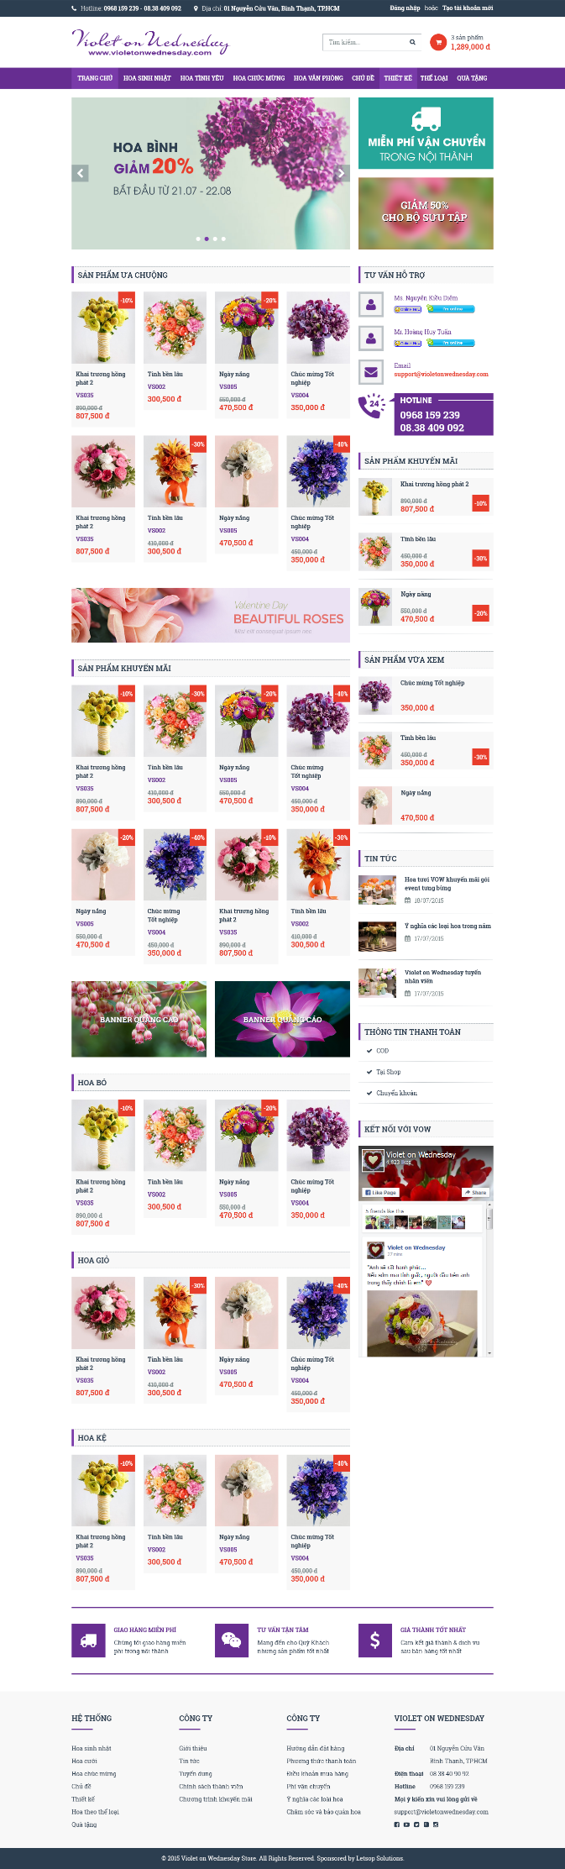

TONG HOP: 7 PATTERN BOOTSTRAP DUNG CHUNG

Pattern 1: Heading giua trang (text-center block)
<div class="text-center mb-5">
<p class="text-uppercase small text-muted">Tagline</p>
<h2 class="fw-bold">Tieu de chinh</h2>
<p class="text-muted mx-auto" style="max-width:600px">
Doan mo ta ngan...
</p>
</div>

Pattern 2: Card Grid responsive (row-cols)
<div class="row row-cols-1 row-cols-md-3 g-4">
<div class="col"><div class="card h-100">...</div></div>
<!-- lap lai -->
</div>

Pattern 3: 2 cot Text + Anh (doi chieu linh hoat)
<div class="row align-items-center g-4">
<div class="col-md-6"><!-- text --></div>
<div class="col-md-6"><!-- anh --></div>
</div>

Pattern 4: Sidebar Split bat doi xung (8+4)
<div class="row g-4">
<div class="col-md-8"><!-- noi dung chinh --></div>
<div class="col-md-4"><!-- widget phu --></div>
</div>

Pattern 5: Section nen mau/anh khac nhau de phan tach
<section class="py-5 bg-light">...</section>
<section class="py-5">...</section>
<section class="py-5" style="background:url(...)">...</section>

Pattern 6: Footer nhieu cot (3 hoac 4)
<footer>
<div class="container">
<div class="row g-4">
<div class="col-md-3">...</div>
<!-- lap lai 3 col nua -->
</div>
</div>
</footer>

Pattern 7: List item nho kieu d-flex (sidebar, blog, comment...)
<div class="d-flex align-items-start mb-3">
<img src="thumb.jpg" width="60" class="rounded me-2 flex-shrink-0">
<div>
<p class="mb-0 fw-semibold small">Tieu de ngan</p>
<small class="text-muted">Thong tin phu</small>
</div>
</div>

💡 Lưu ý
Meo lon nhat: Khi nhin 1 thiet ke bat ky, hay quet theo chieu ngang xem co bao nhieu
'khoi' canh nhau => do la so col-md-x can dung (tong = 12).
Sau do nhin theo chieu doc xem co bao nhieu 'section' mau nen khac nhau
=> moi section la 1 block rieng trong <body>.

